Total energy consumption in different upgrade status

Cooling energy consumption in different upgrade status

图表

Heating energy consumption in different upgrade status

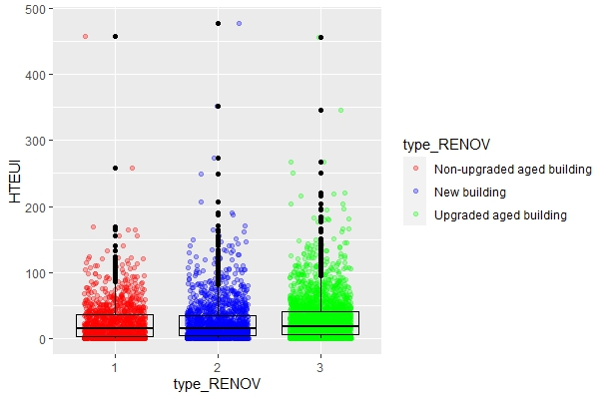

Ventilation energy consumption in different upgrade status

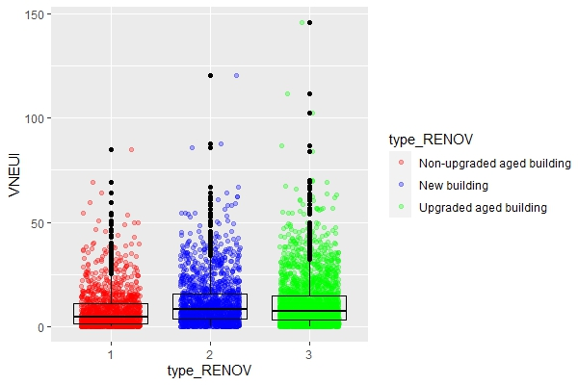

Lighting energy consumption in different upgrade status

